What was Tested? | Input | Expected Outcome / Actual Outcome (text describes, image actual) | Modification
Loading Init Screen | 0 | Expected a loading screen while the program initialises the objects and prepares the data  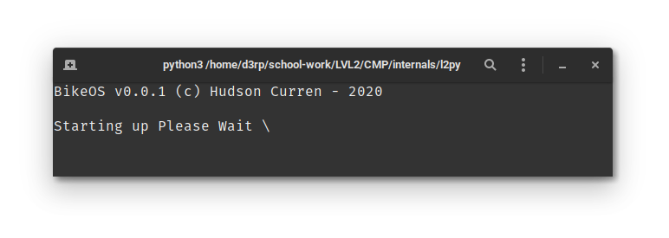 | 0
Getting the race name | The Great Race of 2020  L2CMP | Expected a box saying “lets get teams setup of Race Name  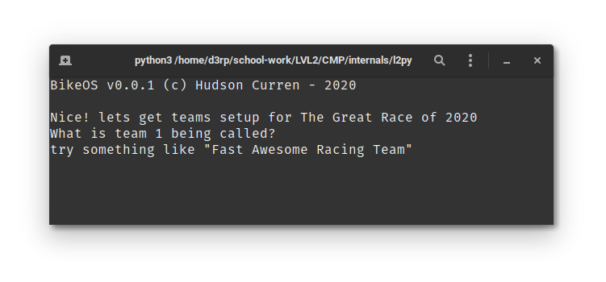 | Was Modified and Fixed, moved the clear() from after the race name was read out, to before  Now the prompt and input is cleared and the race name is printed out
Getting First Team Sorted | Ayush Pillai | Should now ask if there is another racer on the team (accepts yes and no)  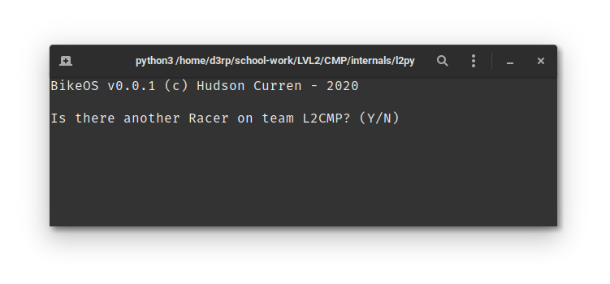 | 0
Saying yes to Adding More Team Members | 0 | Should ask for racer 2  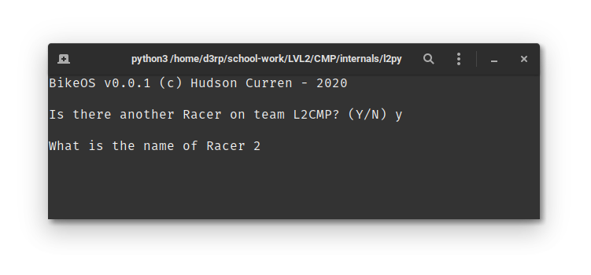 | 0
Adding the rest of the Team Members for Team 1 | Hudson Curren  y  Joe Lidgard  y  Rento Mitani | Should allow this to happen, application should not crash  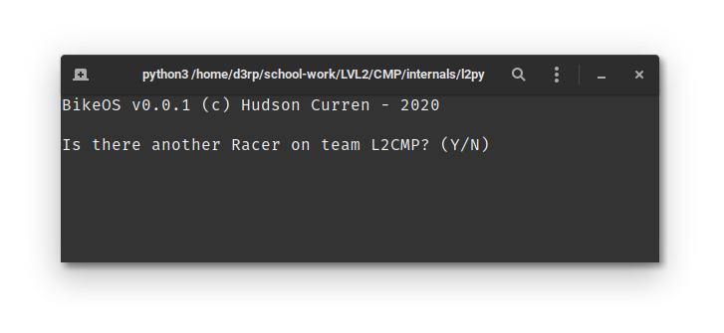 | 0
Moving to the next team | 0 | Should ask if there is another team in the race  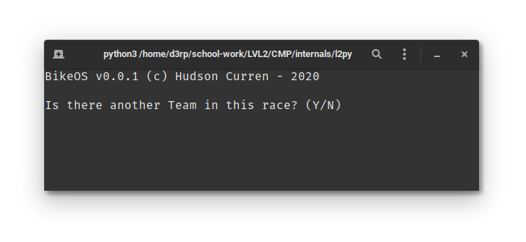 | 0
Adding a Second Team | Y  Linux Gang | Should ask for the first member of the second team (named Linux Gang)  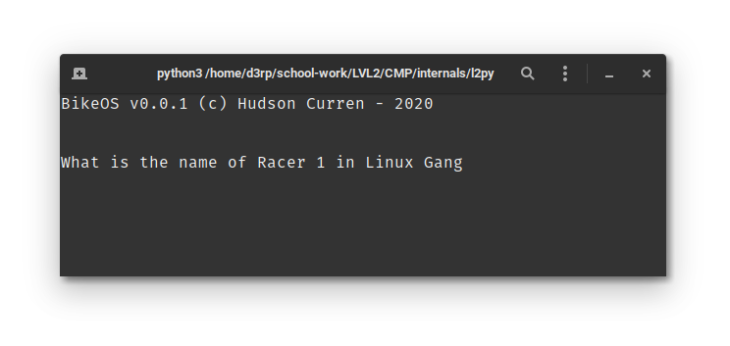 | 0
Adding members to second team | Hudson Curren  y  Liam Urqhart | Should ask for Racer 3, we will be saying no  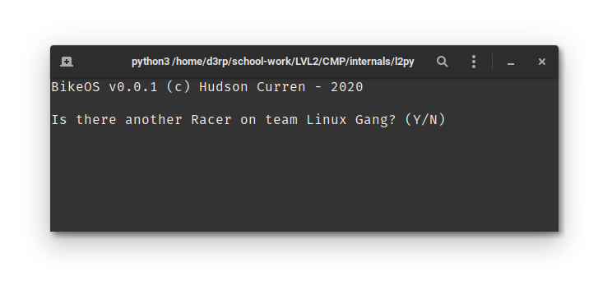 | N/A
Moving on to the actual race | N  n | Should start the “Race”  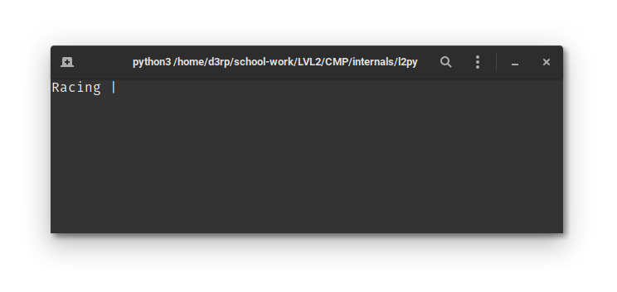 | N/A
Getting Scores | 1  2  3  4  5  6 | Should be asking for places in the race, I will enter 1 – 6  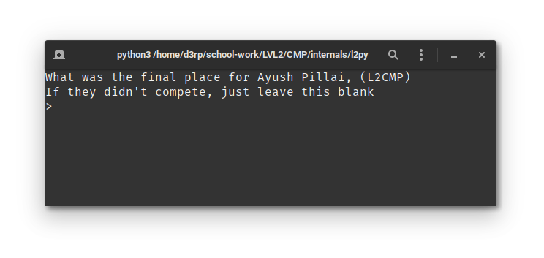 | N/A
Sorting and Printing | 0 | - This process is automatic, it should show the sort and what it is doingf and the pretty print the results, sorted by points value.  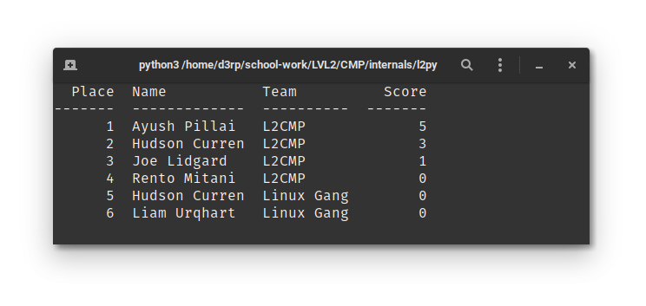 | Changed so the teams are sorted first, meaning that players in teams that have the most points will be put in front of the rest, showing a more accurate representation of the final placement
Using same races for second race | Y | Asks is there is another race with the same races  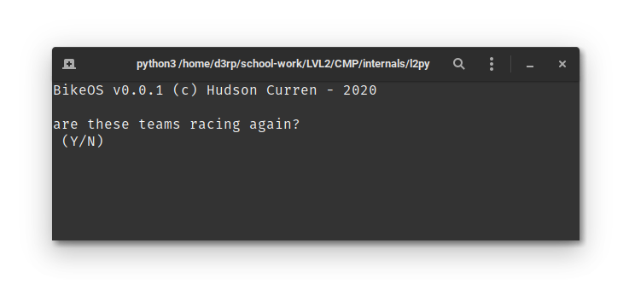 | Added delay by inserting out of place input(), making the user confirm that they’re racing again before starting again.
Racing Again | Y  6  3  2  5  4  1 | Should loop through the same process as before  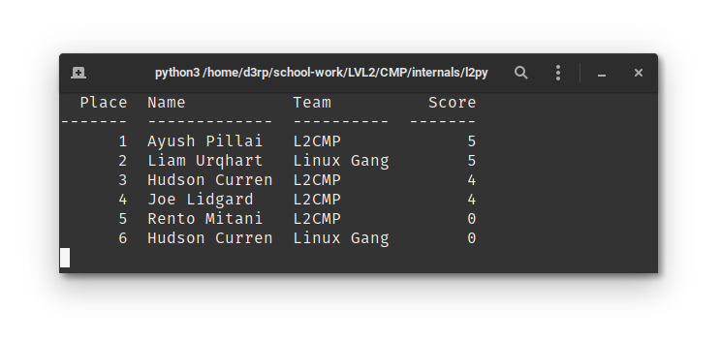  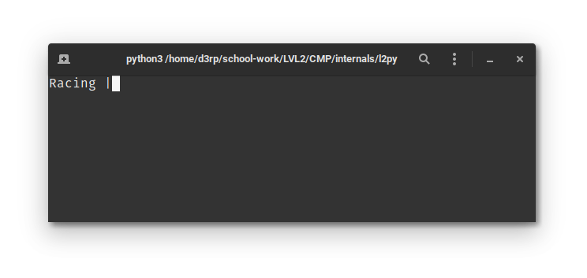
Quitting Application | n | Should return to the shell (in my case its fish)  